**CN Quiz2**

Name: Erwin Wu

Student ID: 17M38147

1. **Write pros and cons of “edge list” and “adjacency matrix”.**

|  |  |  |
| --- | --- | --- |
|  | pros | cons |
| edge list | 1. Simple constructions 2. Saving memory space (<N^2) | 1. Difficult to tell where is a edge. 2. Have to list all the nodes to check the edges.  3. Not that easy to add/delete and edge. |
| adjacency matrix | 1. Easy to judge whether there is an edge between two nodes.  2. Fast access time to check an edge.  3. Easy to add/delete an edge. | 1. Difficult constructions 2.Waste of memory space when the graph is sparse. O(N^2) |

1. **Are these planar? Why?**

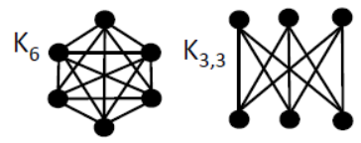

$K_{6}$: It is NOT a planar network because it cannot be turned into without having edges cross. The graph can be made from $K_{5}$ by adding a node which connected to other 5 nodes, so we can say it is an expansion of $K_{5}$, which is definitely not a planar.

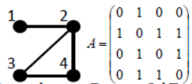 $K_{3.3}$: This is also NOT a planar network, because $K_{3.3}$ has the same nodes and edges like graph $UG$ (shown in slides). It’s just a transformation of $UG$, so according to Kuratowski’s theorem, it is not a planar.

**3. Compute mean degree, density and $L_{3}$ of the right net:**

Since $\sum_{i=1}^{n}{k_{i}=2m}$, we can easily know from the graph that number of edges m=4,

So, we can calculate mean degree: $c=\frac{1}{4}\sum_{i=1}^{4}{ki}=\frac{8}{4}=2$

After that we can get the density $ρ=\frac{2m}{n(n-1)}=\frac{2}{3}$

We need $A^{3}$ to calculate $L_{3}$: $A^{3}={\left[\begin{matrix}0 & 1 & 0 & 0 \\ 1 & 0 & 1 & 1 \\ 0 & 1 & 0 & 1 \\ 0 & 1 & 1 & 0\end{matrix}\right]}^{3}=\left[\begin{matrix}0 & 3 & 1 & 1 \\ 3 & 2 & 4 & 4 \\ 1 & 4 & 2 & 3 \\ 1 & 4 & 3 & 2\end{matrix}\right]$

At last, we can get $L_{3}$ according to : $L_{3}=\sum_{i=1}^{n}{{[A^{3}]}_{ii}=0+2+2+2=6}$